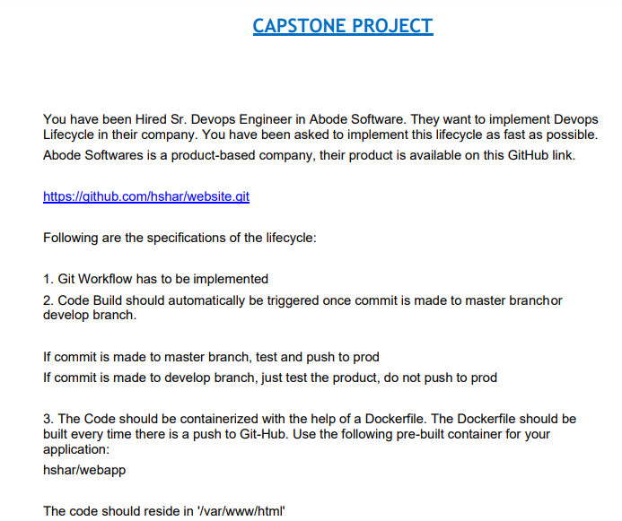

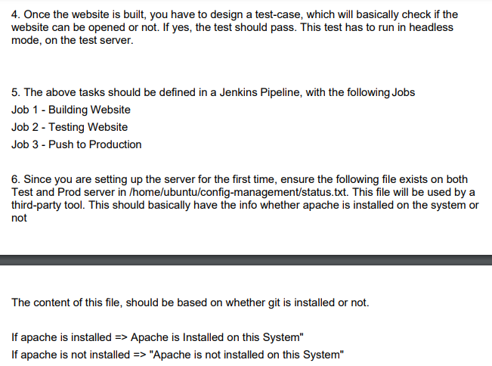

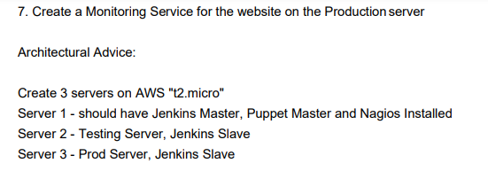

**Solution:**

Capstone project 1

## Instances:(master : t2.small or t2.medium),

## (worker nodes -- build1, build2 ,prod - {ubuntu 20, t2.micro}

## Tasks:

### Installation-

Master server

* Jenkins master
* Puppet master
* Nagios
* Install docker

build1 server

* Jenkins slave node(java install)
* Puppet(nodes)
* Install docker

build2-server

* Jenkins slave(java install)
* Puppet (nodes)
* Install docker

prod-server

* Jenkins slave(java install)
* Puppet (nodes)
* Nagios
* Install docker

### 

### 

### Jenkins jobs-

### 

### Git workflow

* Clone the given repo
* Create a new repo and push the files onto the remote.
* Create a branches develop.

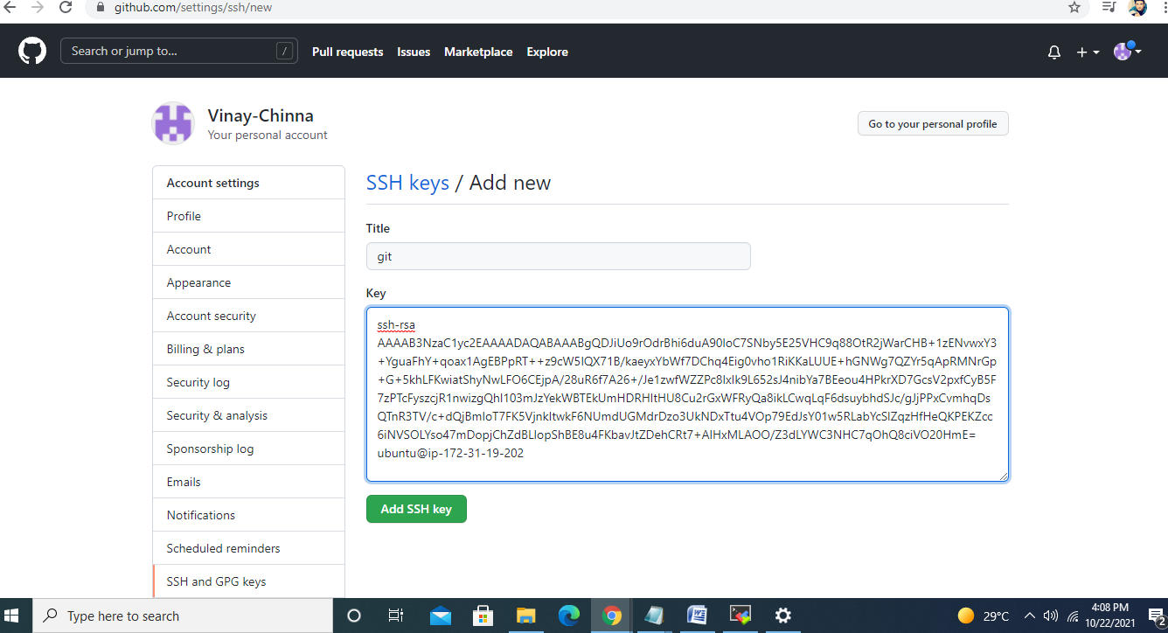

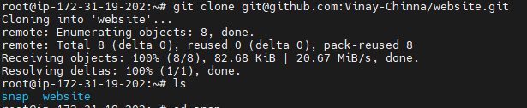

Creating new branch develop

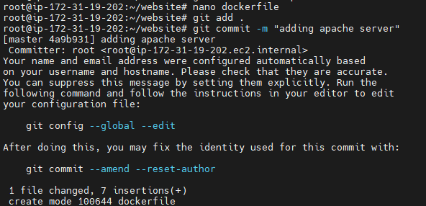

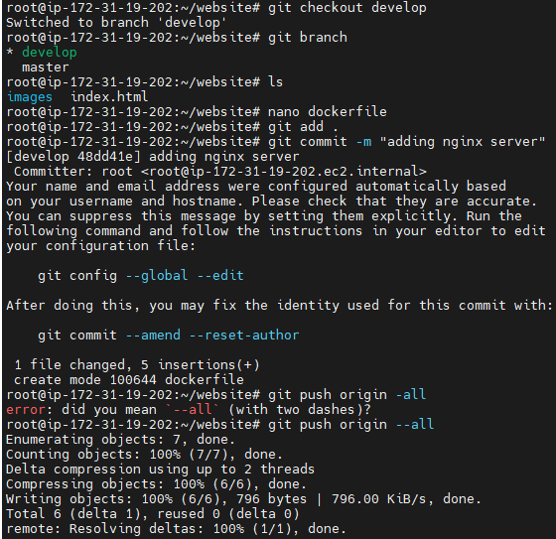

* **git push origin --all**

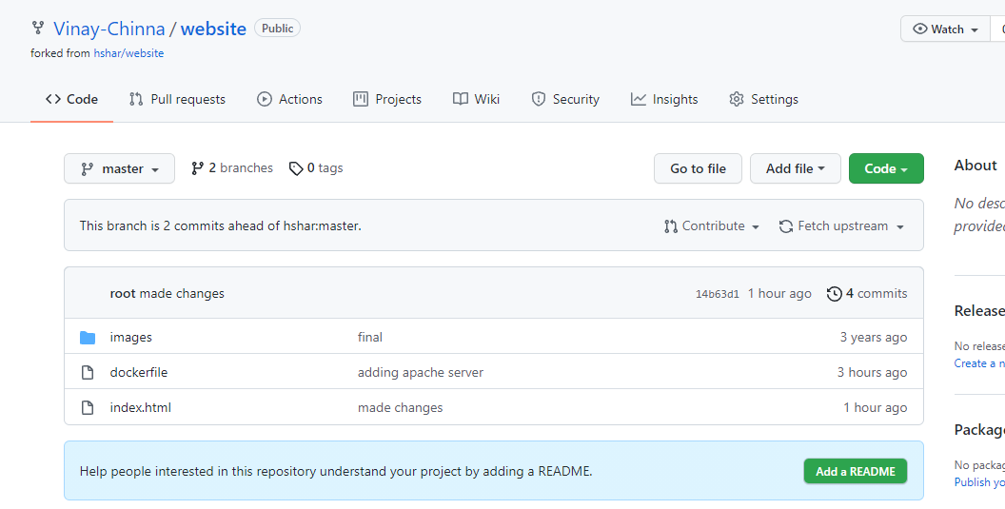

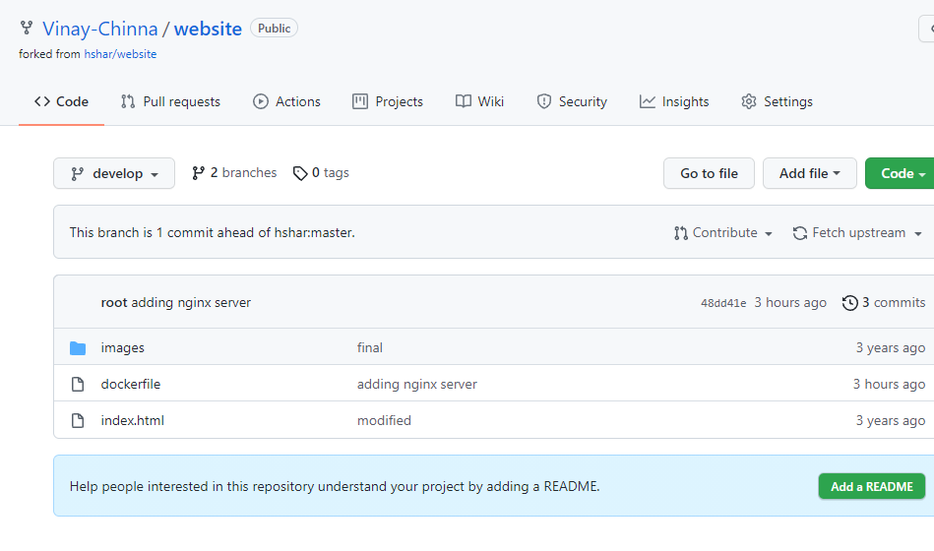

* **Creating Jenkin Jobs**

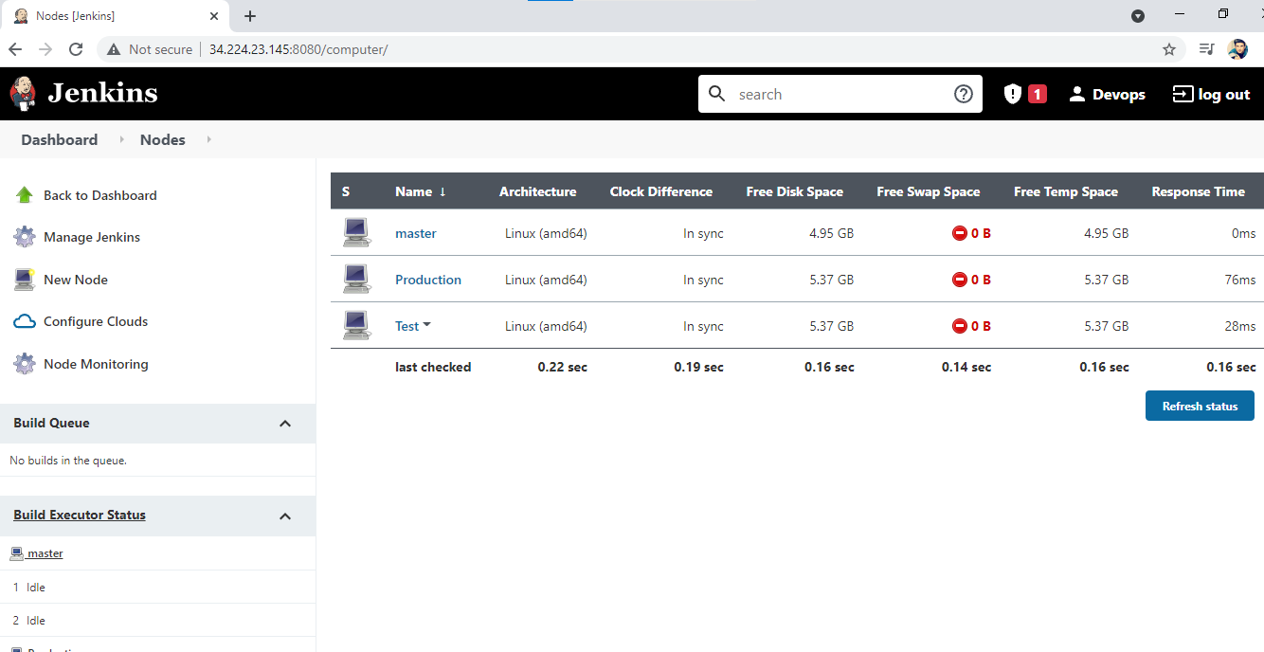

* **Job1**

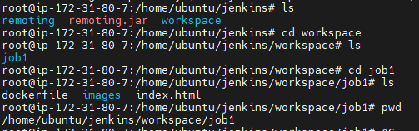

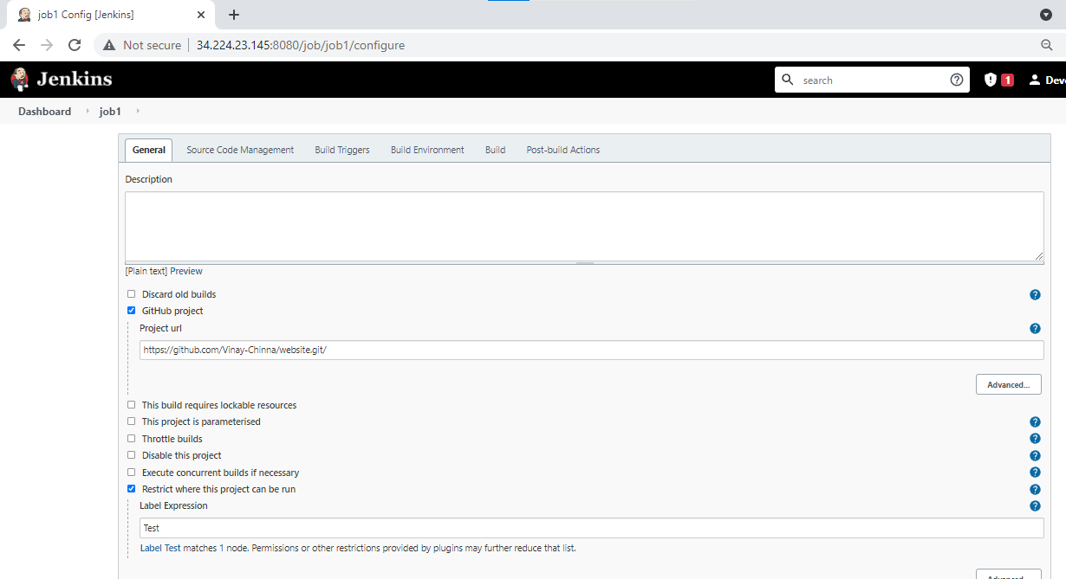

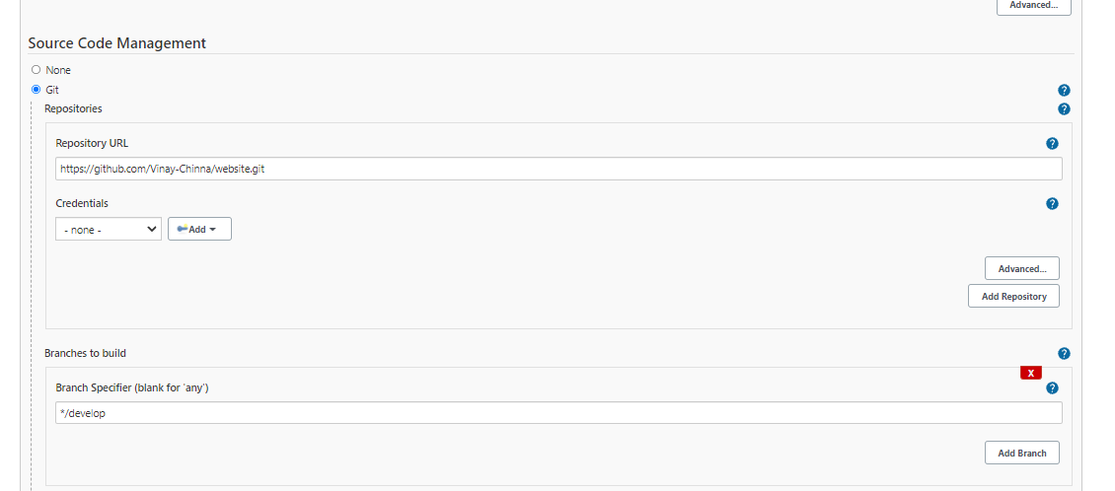

* **Save and apply**

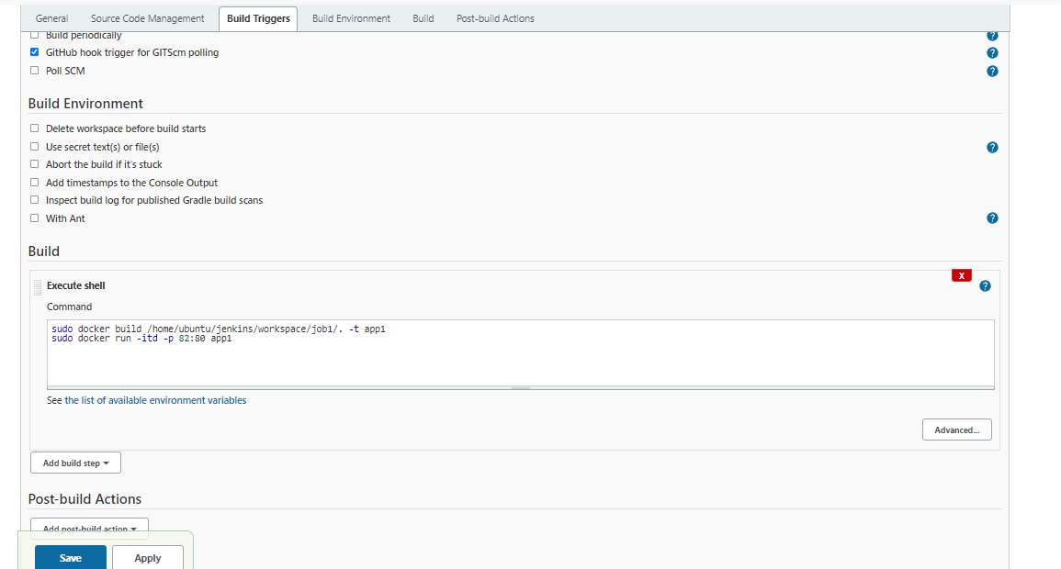

* **Job2**

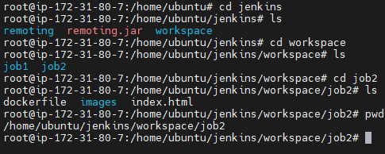

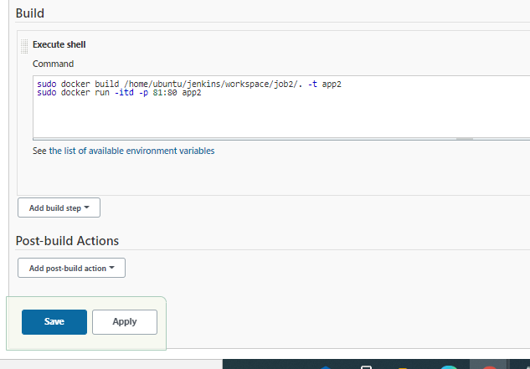

* **Production Job**

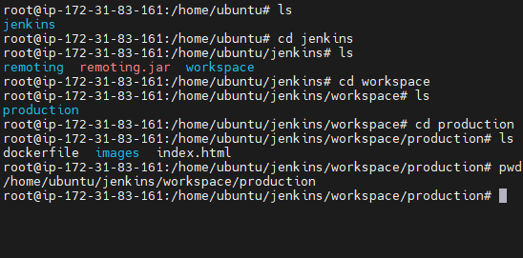

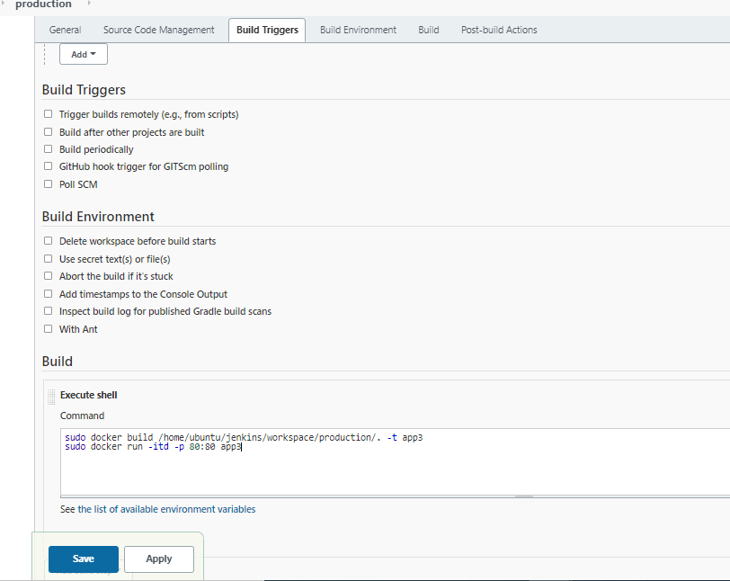

* **Post building job2 execute Production Job**

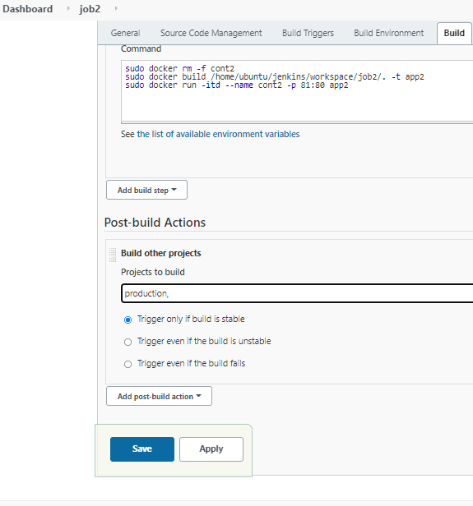

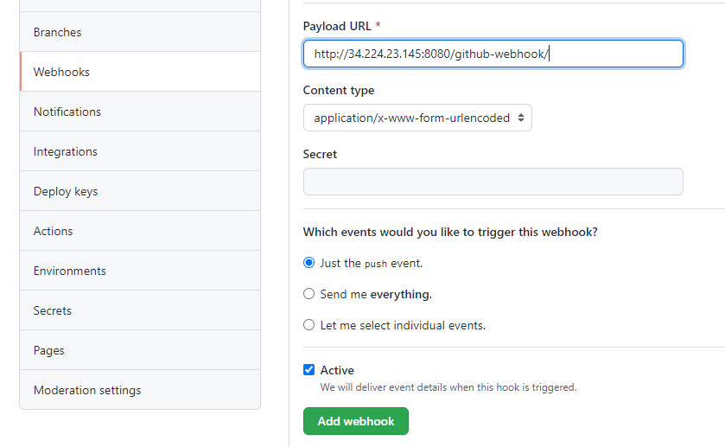

* **Commiting changes to master branch**

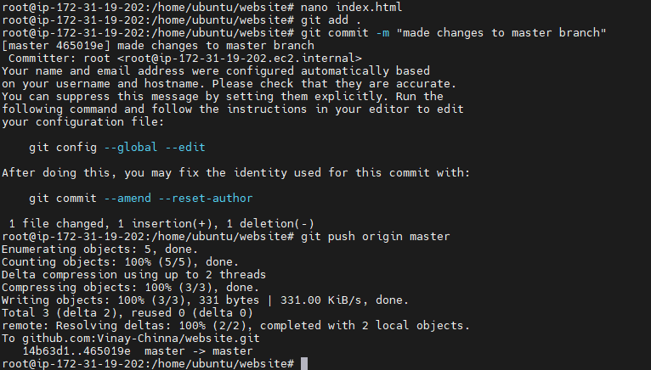

* **Changes commited to master branch and pushed to production**

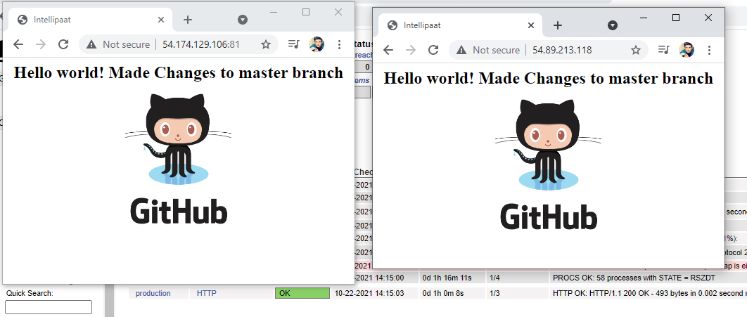

* **Changes commited to develop branch**

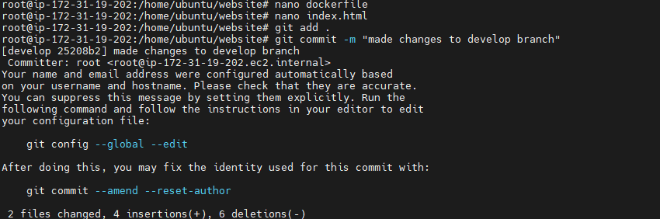

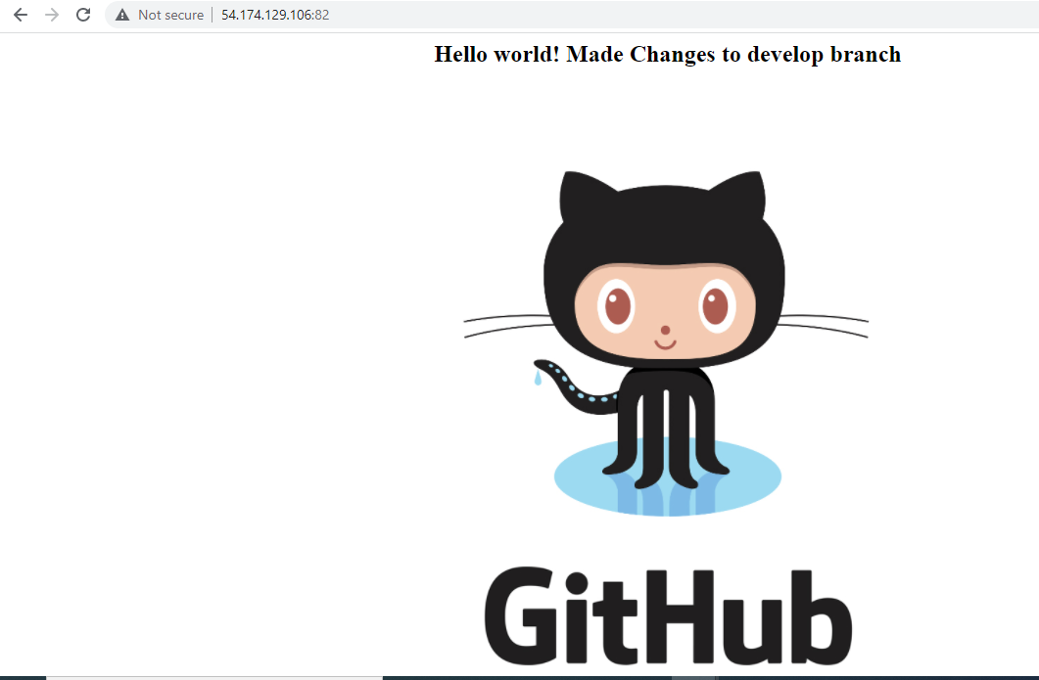

**Configuration management(puppet)**

* /home/ubuntu/config-management/status.txt
  + If apache is installed => “Apache is Installed on this System”
  + If apache is not installed => "Apache is not installed on this System"

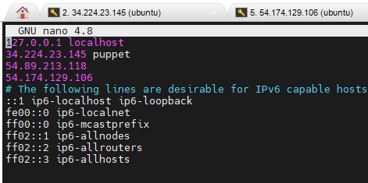

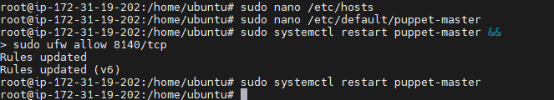

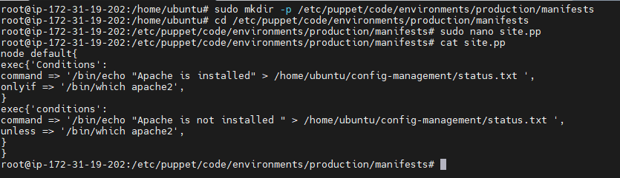

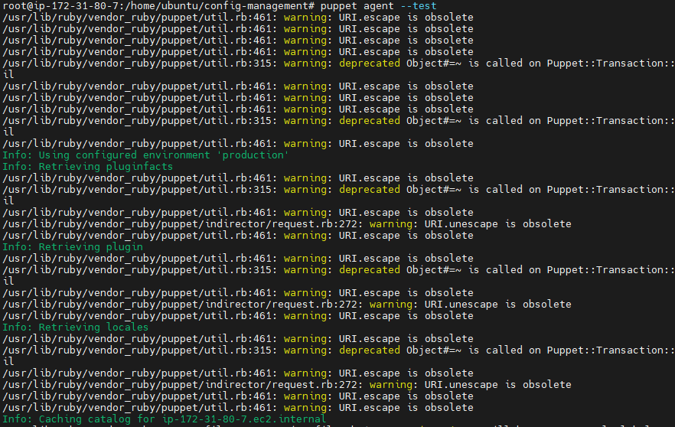

* **Status.txt on one server where apache2 is not installed.**

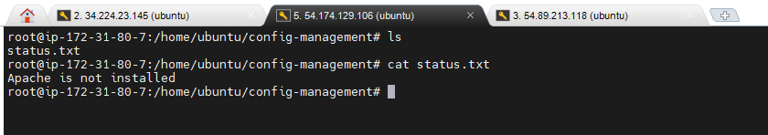

* **apt-get update && apt-get install apache2 –y**
* **Status.txt on one server where apache2 is installed.**

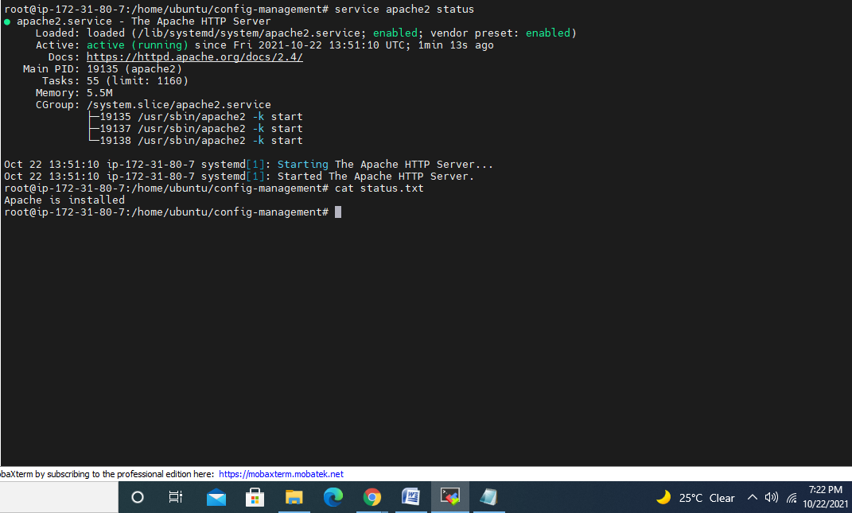

### Continuous monitoring (Nagios)

* Monitor the production server
  + - * Monitor HTTP service

